**Q1) Draw web services execution model?**

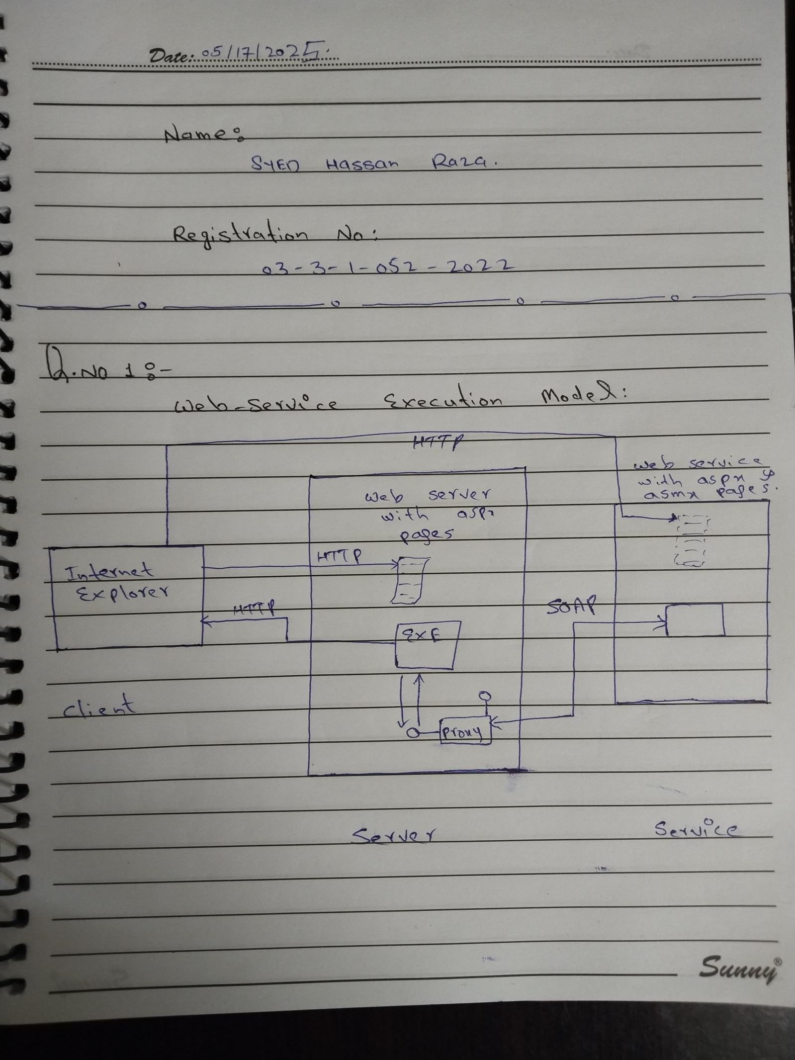

**Q2) Develop a web service with four web methods as follows:**

* Add
* Subtract
* Multiply
* Divid
* In this project, we developed a simple web service using ASP.NET with VB.NET in Visual Studio. The web service, named calculation.asmx, provides four basic mathematical operations: Add, Subtract, Multiply, and Divide. Each method accepts two numeric parameters and returns the result as a string. The project was created as an ASP.NET Web Application (not a Web Site) to ensure a compiled structure and generate the necessary DLL file in the bin directory during the build process.

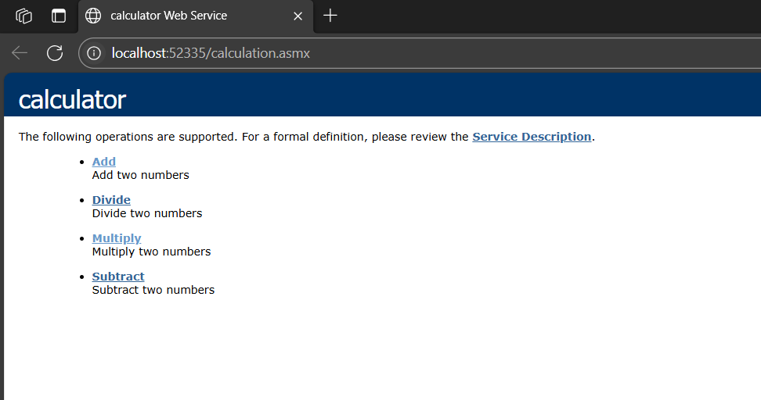

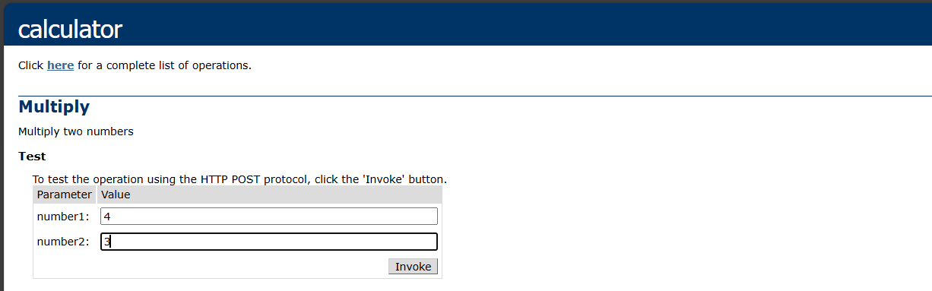

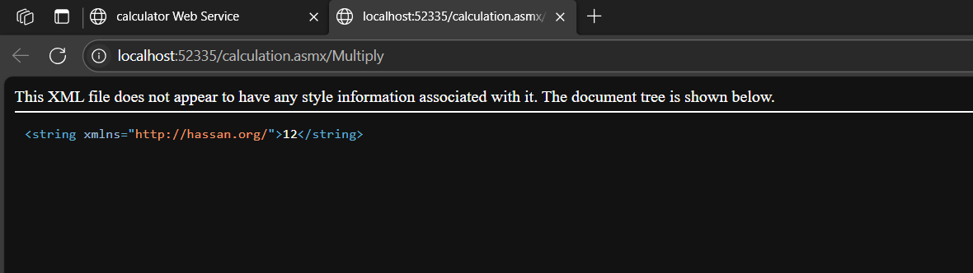

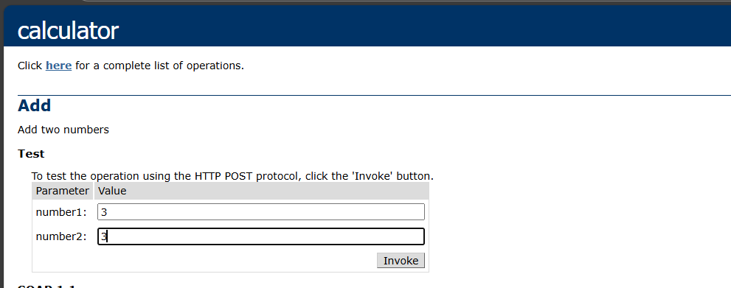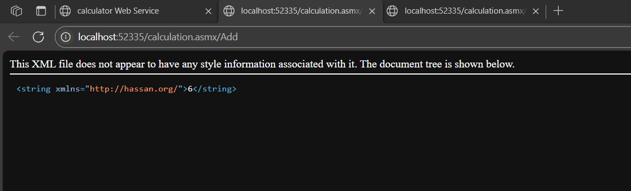

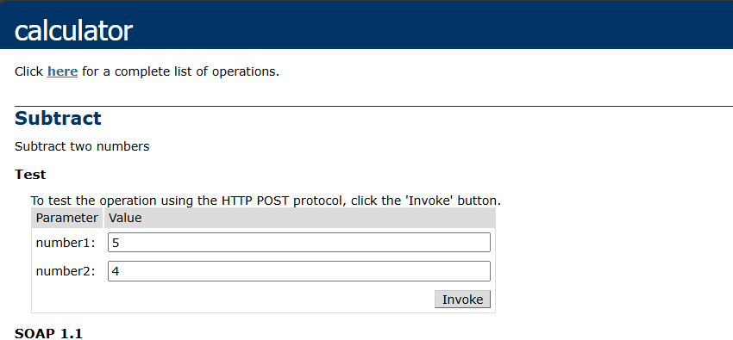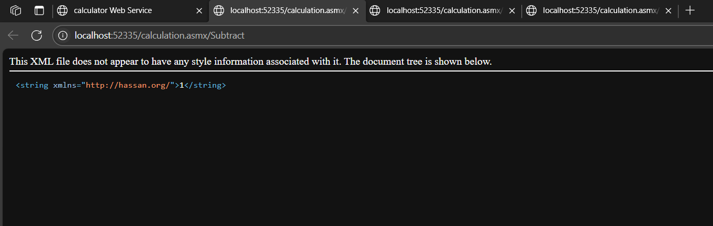

**Q3) Test the web service using browser on local pc.**

* After implementing the web service logic, we hosted it locally using Internet Information Services (IIS). By configuring IIS, we created a virtual directory (alias) named MathLibService and linked it to our project folder. The web service was tested successfully using a browser by accessing the URL http://localhost/MathLibService/MathWebService.asmx, which displayed the list of available methods.
* To allow external access from another device on the same local network, i used the system's IP address (e.g., http://192.168.1.x/MathLibService/calculation.asmx) instead of localhost. Additionally, firewall settings were adjusted to enable HTTP traffic.

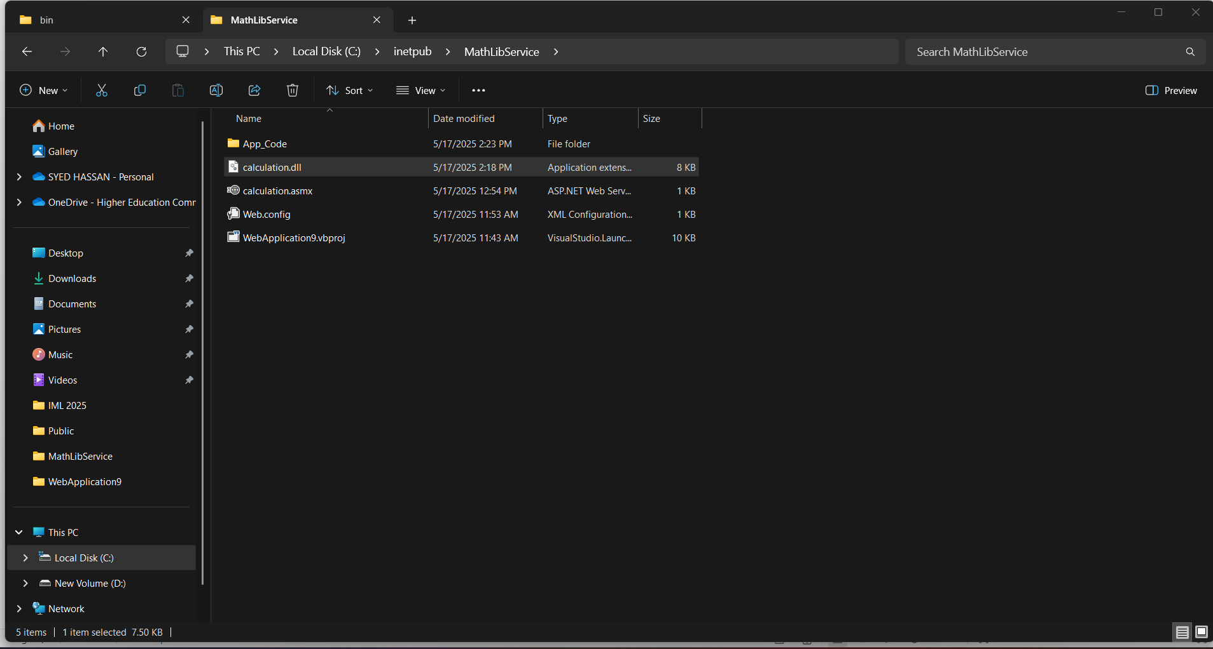

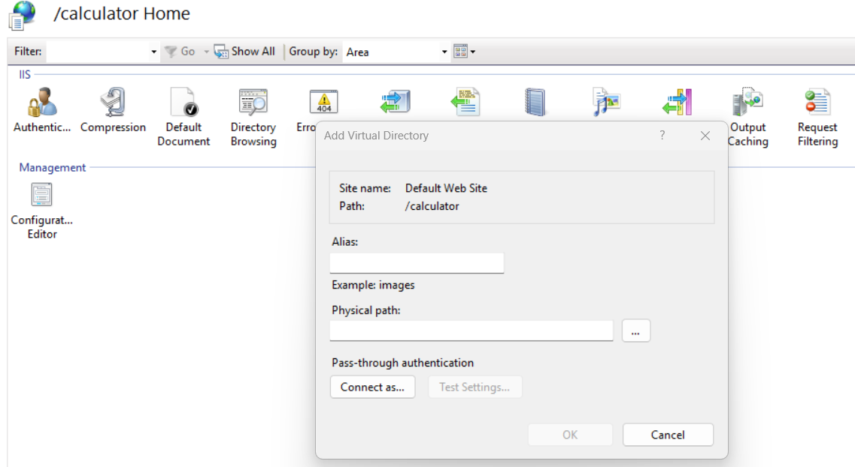

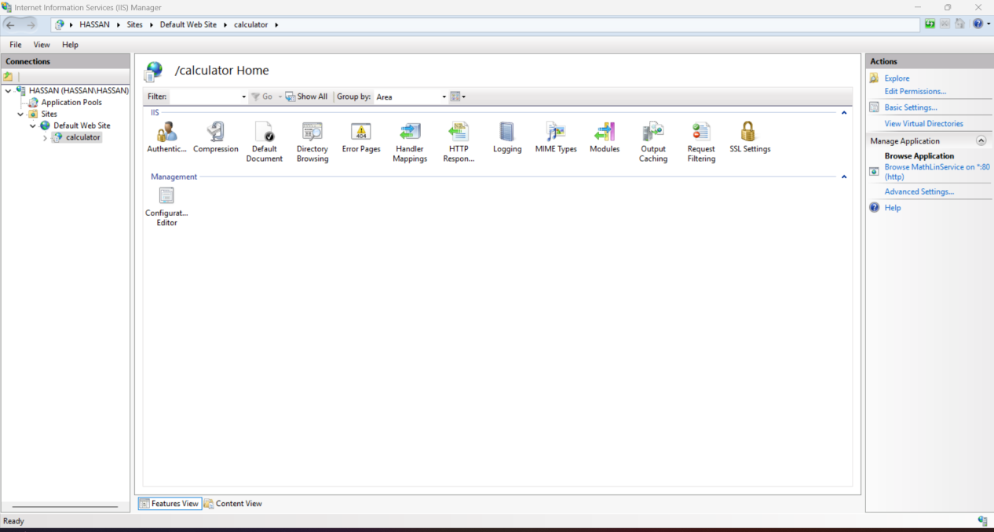

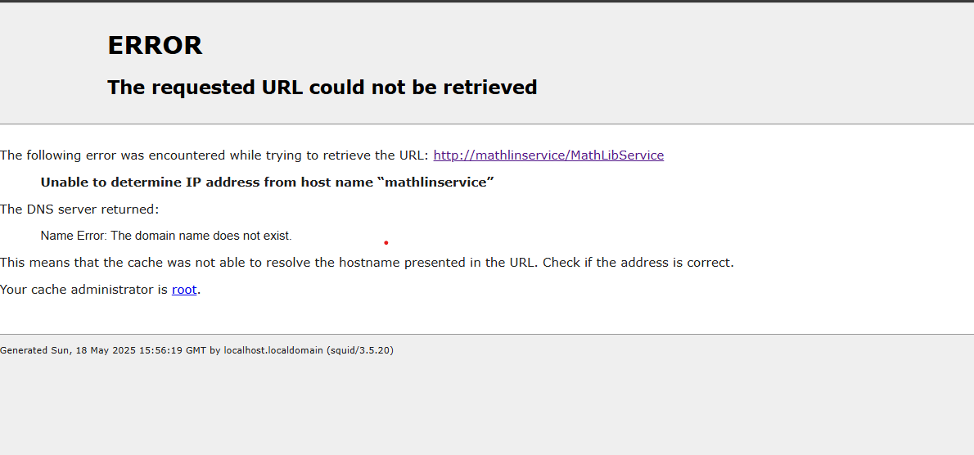

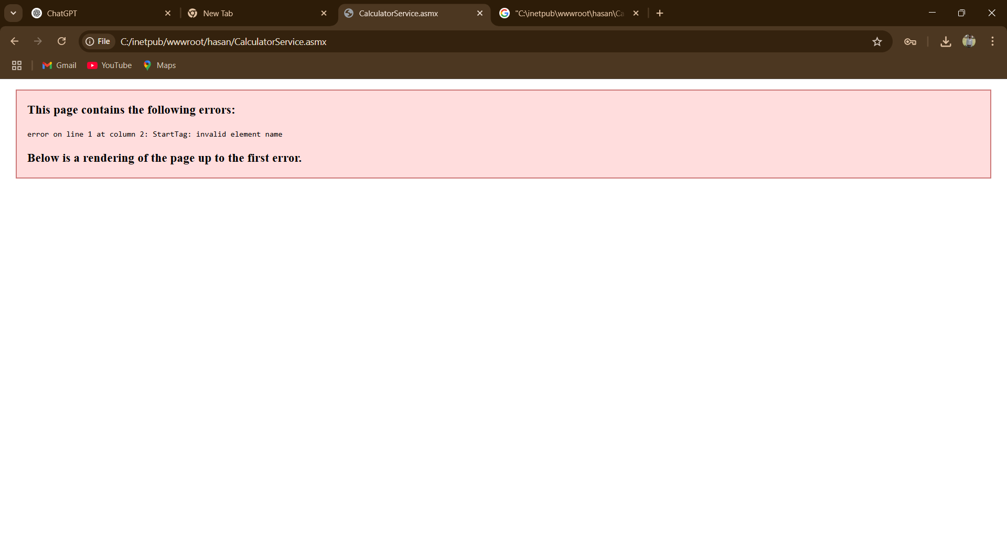

**Q4) Implement a web application “ServiceClient” which will use the MathLibService as a web service.**